Submitted to
The University of Roehampton

In partial fulfilment of the requirements
for the degree of
Master of Science
in
Data Science
By
Your Name

An Intelligent Deep Learning Framework for Early Detection of Liver Cirrhosis and Prognostic Assessment in High-Risk Patients

Declaration
I hereby certify that this report constitutes my own work, that where the language of others is used, quotation marks so indicate, and that appropriate credit is given where I have used the language, ideas, expressions, or writings of others.

I declare that this report describes the original work that has not been previously presented for the award of any other degree of any other institution.

Enter your name here

Enter the date here

Apply your signature here

Acknowledgements
I would like to express my sincere gratitude to all those who contributed, directly or indirectly, to the successful completion of this research project.
First and foremost, I am deeply grateful to my supervisor, Dr Sameena Naaz, for their invaluable guidance, continuous support, constructive feedback, and encouragement throughout the course of this project. Their expertise, patience, and insightful suggestions were instrumental in shaping the direction and quality of this work.
I would also like to extend my appreciation to all academic staff and members of the department who provided a strong foundation of knowledge and support during my studies. Their teachings and academic environment played a significant role in my intellectual and professional development.
My heartfelt thanks go to my family for their unconditional love, understanding, and encouragement throughout this journey. Their constant support, both emotionally and morally, gave me the strength and motivation to persevere through challenges and complete this work successfully.
I am equally grateful to my friends and colleagues for their encouragement, companionship, and willingness to help whenever needed. Their support made this academic journey more enjoyable and less demanding.
Finally, I acknowledge everyone who, in one way or another, contributed to the successful completion of this project. Your support is deeply appreciated.

Abstract
The use of artificial intelligence into clinical decision-making has transformational potential for the early diagnosis and treatment of chronic illnesses. However, widespread adoption of deep learning in healthcare is hampered by the inherent opacity of sophisticated prediction models, which undermines physician trust and limits real-world implementation. This thesis addresses this key hurdle by creating and verifying an intelligent deep learning framework for the early diagnosis and prognosis of liver cirrhosis in high-risk groups. The work uses longitudinal clinical data from the Mayo Clinic Primary Biliary Cirrhosis dataset and employs a strong analytical pipeline that includes rigorous data preprocessing, clinical feature engineering, and synthetic oversampling to resolve class imbalances. Five innovative modelling architectures, including gradient boosting, ensemble stacking, and a unique TabNet-inspired attention-based neural network, are thoroughly tested. To close the gap between predictive performance and clinical transparency, the system incorporates a multi-method explainable AI (XAI) convergence panel and uses Youden's Index for clinically calibrated decision threshold optimisation. Empirical results show good discriminative performance across all models, with ROC-AUC values routinely surpassing 0.82. Threshold optimization considerably improved clinical value, lowering false negatives by more than 75% while retaining good specificity. Multi-method XAI analysis indicated strong feature attribution, with hepatomegaly, prothrombin time, and albumin serving as major predictors, while the TabNet design revealed sequential attention patterns that closely resemble recognized clinical diagnostic procedures. Furthermore, survival analysis produced a Harrell's C-index of roughly 0.78, indicating that model-driven risk stratification successfully differentiated patient trajectories. Overall, this study shows that high-performance predictive modelling may be successfully combined with clinical interpretability and prognostic rigor. The proposed framework provides a clear, reliable, and clinically aligned decision-support tool, increasing the appropriate use of AI in hepatology and opening the road for proactive, personalized cirrhosis care.

Table of Contents
Declaration ii
Acknowledgements iii
Abstract iv
Table of Contents v
List of Figures viii
List of Tables ix
Chapter 1 Introduction 1
1.1 Problem Description, Context and Motivation 1
1.2 Objectives 2
1.3 Methodology 2
1.4 Legal, Social, Ethical and Professional Considerations 2
1.5 Background 3
1.6 Structure of Report 3
Chapter 2 Literature – Technology Review 5
2.1 Literature Review 5
2.2 Technology Review 8
2.3 Summary 10
Chapter 3 Implementation 12
3.1 Data Loading, Quality Audit, and Exploratory Analysis 13
3.1.1 Target Distribution and Censoring Structure 14
3.1.2 Prevalence of Clinical Signs by Cirrhosis Status 15
3.1.3 Correlation Analysis of Clinical Biomarkers 16
3.1.4 Distributional Differences in Biochemical Biomarkers 17
3.2 Feature Engineering: Clinical Composite Indices 18
3.3 Preprocessing, Stratified Partitioning, and Synthetic Oversampling 19
3.4 Algorithm Architectures: Five Advanced Models 20
3.4.1 Histogram Gradient Boosting Classifier (HGBT) 20
3.4.2 DART Gradient Boosting (DART-GB) 21
3.4.3 Deep Stacking Ensemble 21
3.4.4 Calibrated Soft-Vote Ensemble 21
3.4.5 TabNet-Inspired Attention MLP (Custom Implementation) 22
3.5 Training, Threshold Optimisation, and Cross-Validation 23
3.6 Evaluation, Explainability, and Survival Analysis 23
3.6.1 Comprehensive Multi-Metric Evaluation 23
3.6.2 Explainable AI: Three-Method Attribution Convergence 24
3.6.3 Survival Analysis with Kaplan-Meier Estimation 24
3.7 Pipeline Integrity and Methodological Safeguards 25
3.8 Summary 25
Chapter 4 Evaluation and Results 27
4.1 Experimental Setup and Model Configuration 27
4.2 Comparative Model Performance Analysis 28
4.2.1 ROC Curve Analysis and Clinical Operating Regions 28
4.2.2 Cross-Validation Stability and Generalisation 29
4.2.3 Precision–Recall and Calibration Analysis for Imbalanced Clinical Data 30
4.3 TabNet-MLP: Training Behaviour and Learning Dynamics 31
4.4 Clinical Threshold Optimisation 32
4.5 Explainable AI and Clinical Interpretability 34
4.5.1 Multi-Method Feature Importance and Convergence Analysis 34
4.5.2 Sequential Attention and Model Decision Pathways 36
4.5.3 Attention Distribution and Feature Specialisation 37
4.5.4 Clinical Interpretation and Implications 38
4.6 Survival Analysis and Prognostic Assessment 39
4.6.1 Baseline Survival Analysis and Demographic Stratification 39
4.6.2 Model-Driven Risk Stratification 40
4.6.3 Prognostic Discrimination (Harrell’s C-Index) 42
4.7 Summary of Key Findings 43
4.8 Related Works 44
Chapter 5 Conclusion 46
5.1 Future Work 47
5.2 Reflection 48
References 50
Appendices I
Appendix A: Project Proposal II
Appendix B: Project Management III
Appendix C: Artefact/Dataset IV
Appendix D: Screencast V

List of Figures
Figure 1: Four-layer architecture of the proposed cirrhosis detection framework 11
Figure 2: Distribution of histological stages, derived binary target, and clinical outcomes in the PBC dataset. 14
Figure 3: Distribution of clinical outcomes, highlighting the dataset’s longitudinal and survival-analysis structure. 14
Figure 4: Prevalence of key clinical signs across non-advanced (Stages 1–3) and advanced (Stage 4) cirrhosis groups. 15
Figure 5: Correlation matrix and feature–target relationships for key clinical and biochemical variables. 16
Figure 6: Distribution of major biochemical biomarkers across histological stages, illustrating disease progression patterns. 17
Figure 7: ROC Curves: Five Advanced Algorithms 27
Figure 8: 5-Fold Stratified Cross-Validation Performance 28
Figure 9: Precision–Recall Curves and Calibration Analysis 29
Figure 10: Training Dynamics of TabNet-MLP 31
Figure 11: Clinical Decision Threshold Optimisation — TabNet-MLP 32
Figure 12: Three-Method XAI Convergence: Mayo Clinic PBC 33
Figure 13: TabNet Sequential Attention — Feature Selection per Step 35
Figure 14: TabNet Sequential Attention — Feature Importance Matrix 37
Figure 15: Survival Analysis — Mayo Clinic PBC Dataset 38
Figure 16: Risk-Stratified Survival Curves 40

List of Tables
Table 1: Data Dictionary and Clinical Description of Variables 12
Table 2: Algorithm Configurations and Innovation Strategies 26
Table 3: Top 10 Features by Permutation Importance with Clinical Grouping 34
Table 4: Median Survival by Histological Stage 39
Table 4: Survival Outcomes by Model-Predicted Risk Quartile 40
Table 5: Survival Prediction Performance (Harrell’s C-Index) 41

Introduction
The use of artificial intelligence into healthcare has fundamentally altered the landscape of medical diagnosis, prognosis, and illness management. Machine learning and deep learning advances have made large-scale clinical dataset analysis possible, allowing for early illness identification and enhanced risk stratification (Panahi, 2025). Despite their predictive power, many sophisticated models function as opaque systems, restricting clinical interpretability and lowering confidence in real-world medical applications. In healthcare settings where decisions have a direct impact on patient life, model transparency and explainability remain critical.
This research focuses on the creation of an intelligent deep learning framework for the early diagnosis and prognosis of liver cirrhosis in high-risk individuals. The proposed framework combines deep learning architectures and explainable artificial intelligence (XAI) approaches to improve both predicted performance and interpretability. This chapter discusses the research topic, the study objectives, the methodological approach, legal and ethical concerns, pertinent background information, and the general structure of the report.

Problem Description, Context and Motivation
Liver cirrhosis, the terminal stage of chronic liver disease, has a significant global health impact due to its high morbidity and death (Wu et al., 2024). Early identification and precise prognosis are crucial for appropriate management because the disease is frequently asymptomatic until serious consequences emerge. Traditional scoring systems (e.g., MELD, Child-Pugh) depend on static markers and linear assumptions, limiting their capacity to detect nonlinear disease progression and early deterioration, especially in high-risk populations such as Primary Biliary Cirrhosis (Kotak et al., 2024).
While machine learning and deep learning models excel at detecting complex patterns in high-dimensional clinical data (Thottakkara et al., 2016; Wilson & Anwar, 2024), their "black-box" nature makes clinical adoption difficult, since practitioners want visible, auditable reasons for decision-making. To close the gap between predictive accuracy and clinical interpretability, our study created an explainable AI-enhanced deep learning framework for accurate cirrhosis prediction and prognosis.

Objectives
The major goal of this project is to create and test an intelligent deep learning framework for the early diagnosis and prognosis of liver cirrhosis in high-risk individuals.
To accomplish this goal, the following particular objectives are established:
- To review existing literature on liver cirrhosis prediction approaches and identify limitations in current diagnostic models.
- To preprocess and structure longitudinal clinical data from the Mayo Clinic Primary Biliary Cirrhosis dataset to ensure analytical integrity.
- To develop machine learning and deep learning models capable of identifying early disease progression patterns and estimating patient risk trajectories.
- To evaluate model performance using classification and survival-based metrics, including ROC-AUC and concordance index.
- To integrate explainable AI techniques, such as SHAP-based feature attribution, to improve model interpretability and clinical transparency.

Methodology
This study follows a systematic framework that includes data preparation, predictive modelling, and explainable AI. To provide analytical robustness, longitudinal clinical data from the Mayo Clinic Primary Biliary Cirrhosis dataset (Mayo Clinic, 2025) (which includes biochemical, demographic, and clinical variables) is pre-processed using imputation, normalization, and feature engineering. Machine learning and deep learning models are then created to capture nonlinear patterns for early cirrhosis identification and longitudinal risk assessment. To improve interpretability, SHAP-based feature attribution quantifies predictor contributions, promoting transparency and clinical validity. Model performance is assessed using accuracy, recall, F1-score, ROC-AUC, and concordance index, as well as comparisons to recognized clinical grading systems to determine predictive and practical value.

Legal, Social, Ethical and Professional Considerations
This research focuses on major ethical, legal, and professional aspects for AI in healthcare. It employs completely anonymised secondary clinical data while complying to accepted medical research and privacy norms. To improve diagnostic outcomes and reduce algorithmic bias, the system incorporates explainable AI for transparency and clinical validation. Rigorous academic norms, such as accurate citation, explicit methodology, and detailed documentation, promote repeatability and scientific integrity.

Background
Liver cirrhosis is the last and irreversible stage of chronic liver disease, characterized by increasing fibrosis and decreased liver function. It is a substantial contributor to global morbidity and death, putting enormous strain on healthcare systems worldwide (Martini et al., 2023). Disease development is often sluggish, and patients may stay asymptomatic until serious problems arise, resulting in limited treatment effectiveness and poor survival results.
High-risk groups, particularly those with Primary Biliary Cirrhosis, have very varied disease trajectories driven by biochemical, genetic, and pharmacological variables (Battle et al., 2025). This heterogeneity hinders reliable prognostic evaluation using conventional approaches.
Historically, prognostic assessment was based on statistical survival models and clinical grading systems generated from longitudinal datasets such as those from the Mayo Clinic (Dantuluri, 2026). While effective, these models rely heavily on linear assumptions and have limitations in describing nonlinear and time-dependent illness processes.
Recent improvements in machine learning have shown promising results in clinical prediction problems. However, many existing techniques rely on static categorization rather than longitudinal progression modelling. This constraint emphasizes the need for prediction frameworks that can simulate temporal illness progression and patient-specific trajectories (Dantuluri, 2026).
Deep learning models are effective tools for modelling complicated relationships in multidimensional clinical data. However, their lack of interpretability remains a significant hurdle to clinical use. Explainability is critical in healthcare settings to build confidence and facilitate decision-making (Adeniran et al., 2024). As a result, there is a rising interest in merging deep learning with explainable AI to create transparent and dependable clinical decision-support systems.

Structure of Report
This paper moves from the theoretical underpinnings to framework implementation and assessment.
Chapter 2 examines the literature on liver cirrhosis, clinical diagnostics, healthcare machine learning, and explainable AI, highlighting research gaps that prompted this study.
Chapter 3 describes the framework's implementation, which includes data pretreatment, exploratory analysis, feature engineering, and ML/DL model construction.
Chapter 4 discusses model evaluation with classification and survival measures, explainability analysis, and comparisons to recognized clinical scoring systems.
Chapter 5 summarizes the important findings, contributions, and limits, as well as recommendations for future study, such as external validation and multimodal data integration.

Literature – Technology Review
This chapter critically reviews existing literature on artificial intelligence (AI) and deep learning approaches for the detection and prognosis of liver cirrhosis. It examines the clinical challenges of current diagnostic methods and evaluates how recent computational advances attempt to address issues such as disease heterogeneity, temporal progression, and limited interpretability. The review provides the foundation for the proposed methodology by identifying key gaps in accuracy, generalisability, and clinical usability.

Literature Review
Liver cirrhosis represents the terminal stage of chronic liver disease and remains a significant global health challenge due to its progressive nature, high mortality, and substantial healthcare burden (Fadlallah et al., 2025; Duo et al., 2025). The disease is characterised by irreversible hepatic fibrosis, structural distortion, and declining liver function, with progression often occurring silently during early stages (Thiele et al., 2025). This asymptomatic phase presents a critical clinical limitation, as patients are frequently diagnosed only after transition to decompensated cirrhosis, where complications such as ascites, portal hypertension, and hepatic encephalopathy significantly reduce survival outcomes. Consequently, early detection and accurate prognostic assessment remain central challenges in hepatology.
This review evaluates computational methods for the early diagnosis and longitudinal prognosis of liver cirrhosis, emphasizing predictive accuracy, temporal modeling, and clinical interpretability. Literature synthesis identifies four core paradigms: (i) traditional machine learning ensembles, (ii) deep learning and tabular-sequence architectures, (iii) survival-aware prognostic models, and (iv) explainable AI (XAI) integrated with advanced data engineering.
A further layer of complexity arises from the heterogeneity of disease progression. Conditions such as Primary Biliary Cirrhosis exhibit highly variable trajectories influenced by immunological, biochemical, and therapeutic factors (Chen et al., 2025; Chowdhury et al., 2025). Similarly, differing aetiologies, including viral hepatitis, alcohol-related liver disease, and metabolic disorders, result in distinct progression patterns despite converging on cirrhosis as a final outcome. This variability limits the effectiveness of traditional diagnostic frameworks, which often rely on generalised assumptions rather than personalised risk modelling.
Conventional diagnostic methods exhibit several well-documented limitations. Liver biopsy, although considered the gold standard, is invasive and subject to sampling bias, while imaging modalities such as CT and MRI lack sensitivity in detecting early-stage fibrosis. Biochemical markers, although clinically useful, provide only static snapshots of liver function and fail to capture the temporal dynamics of disease progression. Collectively, these limitations highlight a fundamental gap: existing clinical tools are insufficient for modelling the complex, dynamic, and heterogeneous nature of cirrhosis progression, thereby motivating the exploration of data-driven approaches.
Artificial intelligence (AI) and deep learning have emerged as promising solutions to these challenges, enabling the analysis of high-dimensional and heterogeneous clinical data (Asif et al., 2025). Unlike traditional statistical models, machine learning algorithms can capture complex, non-linear relationships and uncover latent patterns that are not readily observable. Early approaches, including support vector machines and ensemble methods, demonstrated improved diagnostic accuracy; however, their reliance on manual feature engineering and limited ability to model temporal dependencies restricts their applicability in longitudinal disease contexts.
More advanced deep learning architectures, including Convolutional Neural Networks (CNNs), Recurrent Neural Networks (RNNs), and Transformer-based models, have significantly enhanced predictive performance across clinical applications. CNNs are particularly effective in imaging-based diagnosis, while RNNs and Transformers are better suited for sequential and longitudinal data modelling. These architectures enable automatic hierarchical feature extraction, allowing for more accurate representation of complex biological systems. However, despite these advantages, a major limitation persists: the lack of interpretability, often referred to as the “black-box” problem, which restricts clinical adoption (Fahim et al., 2025).
Recent research has attempted to address these limitations through multimodal and explainable AI frameworks. Multimodal models, such as FLARE, integrate radiological, pathological, and clinical data to achieve high predictive performance, demonstrating the value of combining heterogeneous data sources (Qu et al., 2026). Similarly, hybrid CNN-Transformer models have achieved high accuracy in liver tumour detection, while attention-based transformer models such as Bio-Clinical BERT have shown strong capability in modelling electronic health records, achieving AUC values above 0.95 (Sarfraz et al., 2025; Wang et al., 2025). These approaches highlight a clear shift toward integrated and data-rich modelling strategies.
In parallel, explainable AI techniques, particularly SHAP and feature attribution methods, have been introduced to improve model transparency and support clinical decision-making (Alum, 2025; Kalasampath et al., 2025). While these methods enhance interpretability, they are frequently applied post hoc rather than being embedded within the model architecture, limiting their effectiveness in real-time clinical settings.
Prognostic modelling has also advanced through the integration of survival analysis with machine learning. Models such as TabNet-Cox and neural survival networks have demonstrated the ability to predict patient outcomes using high-dimensional clinical data, achieving moderate to high predictive performance (Dong & Qian, 2026; Zhang et al., 2025). However, many of these approaches are constrained by small datasets, limited generalisability, or insufficient modelling of temporal disease progression.
Despite these advancements, several critical limitations remain across the literature. First, many studies rely on retrospective, single-source datasets, raising concerns about overfitting and external validity (Xiong et al., 2025). Second, a large proportion of models focus on static prediction tasks, failing to capture the longitudinal nature of chronic diseases such as cirrhosis. Third, while high-performing ensemble models (e.g., XGBoost-based systems) achieve impressive AUC scores, they often lack interpretability, limiting their clinical usability (Rao et al., 2025; Khorsand et al., 2025). Finally, most existing approaches treat classification, survival analysis, and explainability as separate components, rather than integrating them into a unified framework.
These limitations define a clear research gap: the absence of robust, interpretable, and generalisable predictive systems that effectively model longitudinal clinical data while maintaining high predictive performance. Addressing this gap requires a balanced approach that combines the strengths of ensemble learning, deep learning, and explainable AI, while remaining aligned with real-world clinical data constraints.
This study directly responds to these challenges by proposing a hybrid, ensemble-based framework that integrates multiple modelling paradigms to improve predictive accuracy and robustness. By leveraging structured clinical data, incorporating explainability techniques, and evaluating both diagnostic and prognostic performance, the proposed approach aims to bridge the gap between high-performing AI models and clinically applicable decision-support systems.

Technology Review
This review evaluates computational methods for the early diagnosis and longitudinal prognosis of liver cirrhosis, emphasizing predictive accuracy, temporal modeling, and clinical interpretability. Literature synthesis identifies four core paradigms: (i) traditional machine learning ensembles, (ii) deep learning and tabular-sequence architectures, (iii) survival-aware prognostic models, and (iv) explainable AI (XAI) integrated with advanced data engineering.
Classical machine learning algorithms, including Random Forests (RF), eXtreme Gradient Boosting (XGBoost), LightGBM, and Support Vector Machines (SVM), have consistently demonstrated strong baseline performance in hepatology risk prediction, frequently achieving area under the curve (AUC) values exceeding 0.85 in retrospective clinical studies (Rao et al., 2025; Xiong et al., 2025; Gao & Duan, 2025). Their effectiveness stems from the ability to model non-linear feature interactions, handle heterogeneous clinical variables, and maintain robustness in noisy environments. However, despite these advantages, such models are fundamentally constrained by their static learning paradigm, operating on cross-sectional representations of patient data. This limitation is particularly critical in cirrhosis, where disease progression is inherently temporal and dynamic. Consequently, their inability to explicitly model longitudinal trajectories significantly reduce their suitability for real-world prognostic applications (Zhai et al., 2024). Furthermore, while ensemble methods often achieve high predictive accuracy, they frequently lack intrinsic transparency, thereby limiting their clinical interpretability without additional post-hoc techniques.
To overcome these limitations, deep learning architectures have emerged as more flexible and expressive alternatives. Multi-layer perceptrons (MLPs) and Artificial Neural Networks (ANNs) have demonstrated improved capability in capturing complex, high-dimensional clinical relationships, often outperforming traditional statistical scoring systems in cirrhosis and hepatocellular carcinoma prediction tasks (Zhang et al., 2025; Wu et al., 2024). More importantly, recent advancements in attention-based and transformer-derived models, such as TabNet and Bio-Clinical BERT, have introduced mechanisms for modelling sequential and context-dependent clinical data, enabling more accurate representation of longitudinal electronic health records (EHRs). These architectures incorporate attention mechanisms that not only enhance predictive performance but also provide a degree of instance-level interpretability, addressing one of the core limitations of earlier neural networks (Wang et al., 2025; Dong & Qian, 2026).
Despite these advantages, not all deep learning approaches are equally suitable. Hybrid CNN-Transformer and radiomics-based multimodal frameworks, including FLARE and ALARM, achieve state-of-the-art performance in imaging-driven oncology contexts (Qu et al., 2026; Sarfraz et al., 2025). However, their reliance on high-dimensional imaging data and substantial computational resources makes them misaligned with structured, tabular, longitudinal datasets, such as the Mayo Clinic Primary Biliary Cirrhosis dataset used in this study. This highlights an important practical constraint: model suitability must be determined not only by performance but also by data modality and deployment feasibility.
Given the progressive and time-dependent nature of cirrhosis, survival analysis remains a critical component of prognostic modelling. The Cox Proportional Hazards model continues to serve as the clinical benchmark due to its interpretability and theoretical grounding. However, its reliance on linear assumptions and proportional hazard constraints limits its ability to capture complex, non-linear disease dynamics (Zhai et al., 2024). Machine learning extensions, such as Random Survival Forests (RSF) and gradient-boosted survival models, address some of these limitations by modelling non-linear relationships, yet they still lack tight integration with deep feature learning (Zhang et al., 2025).
In contrast, deep survival models, including DeepSurv, Cox-nnet, and TabNet-Cox, represent a significant advancement by combining neural representation learning with survival analysis objectives. These models directly learn non-linear hazard functions from high-dimensional inputs while maintaining alignment with survival theory, achieving concordance indices in the range of 0.79–0.86 (Dong & Qian, 2026; Zhai et al., 2024). Their ability to jointly model feature complexity and temporal risk evolution makes them particularly well-suited for chronic disease prognosis, where both accuracy and temporal sensitivity are essential.
A persistent challenge across all advanced models is the “black-box” problem, which remains a major barrier to clinical adoption. In response, explainable artificial intelligence (XAI) has become an indispensable component of modern healthcare analytics. Among available methods, SHapley Additive exPlanations (SHAP) has emerged as the most robust and theoretically grounded approach, providing additive, game-theoretic feature attributions that are consistent and globally interpretable (Rao et al., 2025; Xiong et al., 2025; Dong & Qian, 2026). Unlike alternative methods such as LIME or Grad-CAM, SHAP offers model-agnostic consistency and local-global interpretability, making it particularly suitable for clinical decision support. Complementary techniques, including attention visualization and integrated gradients, enable temporal and sequential interpretability; however, SHAP remains the preferred method due to its mathematical rigor and regulatory alignment (Wang et al., 2025; Gao & Duan, 2025).
Equally critical to model performance is the quality and structure of the underlying data. Clinical datasets are inherently noisy, imbalanced, and incomplete, necessitating robust data engineering strategies. Techniques such as Synthetic Minority Oversampling combined with Edited Nearest Neighbors (SMOTE-ENN) effectively address class imbalance while preserving decision boundary integrity. Similarly, Multiple Imputation by Chained Equations (MICE) enables statistically sound handling of missing longitudinal data, ensuring that imputation does not distort physiological relationships (Xiong et al., 2025; Zhai et al., 2024). These preprocessing strategies are essential for maintaining both model validity and clinical reliability.
Rationale for Technology Selection
This study employs a hybrid ensemble framework integrating Histogram-Based Gradient Boosting (HGBT), DART Gradient Boosting (DART-GB), and a TabNet-inspired MLP, fused via Deep Stacking and Soft Voting. Single-model approaches were excluded for their limited generalizability and inability to capture complex, non-linear interactions. HGBT provides computational efficiency and native missing-value handling, while DART-GB employs dropout regularization to prevent overfitting in imbalanced data. The TabNet-MLP complements these with adaptive, instance-wise feature selection and deep representation learning. At the meta-level, Deep Stacking learns optimal weightings from diverse error distributions, while Soft Voting aggregates calibrated probabilities to minimize variance. Specifically optimized for the structured Mayo Clinic Primary Biliary Cirrhosis dataset, this architecture synergizes gradient boosting and deep learning to deliver a robust, clinically reliable system for early cirrhosis detection and precise risk stratification.

Summary
This chapter critically reviewed the clinical and computational landscape for liver cirrhosis prognosis. Traditional diagnostic methods struggle to capture disease heterogeneity and dynamic progression. While AI and deep learning show strong predictive potential, persistent challenges, including limited generalisability, inadequate temporal modelling, and poor interpretability, hinder clinical adoption.
No single modelling approach adequately addresses these gaps: conventional machine learning offers robustness but lacks temporal sensitivity; deep learning provides representational power but sacrifices interpretability; survival models add prognostic value but often rely on restrictive assumptions.
These insights directly motivate this study's methodological design: a hybrid ensemble framework integrating gradient boosting and deep learning, augmented with explainability techniques to ensure clinical transparency. By combining complementary algorithmic strengths and aligning with structured clinical data characteristics, the proposed approach targets the limitations identified in current literature.
Overall, this chapter establishes the rationale for developing a robust, interpretable, and clinically actionable predictive framework for liver cirrhosis management.

Implementation
This chapter outlines the implementation of the proposed framework for early detection and prognostic assessment of liver cirrhosis (see Figure 1). The model is developed using the Mayo Clinic PBC dataset (1974–1984), containing 7,905 longitudinal records from 418 patients (~19 observations per patient). To ensure relevance to real-world clinical use, cross-sectional classifiers were employed.
As shown in Figure 1, the pipeline is structured into four layers: data preparation, feature engineering, a five-model ensemble, and evaluation with clinical deployment, corresponding to the eight phases described in this chapter.
The entire pipeline was designed to be reproducible and leakage-free: random seeds were fixed (42), transformations were applied within their respective data splits, and potential biases were systematically controlled. Subsequent sections detail each component of the framework.
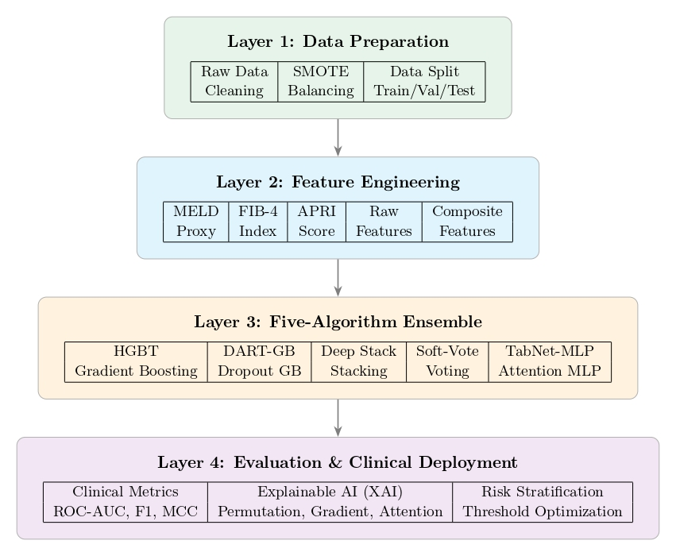
Figure 1: Four-layer architecture of the proposed cirrhosis detection framework

Data Loading, Quality Audit, and Exploratory Analysis
The dataset was loaded and standardised to ensure consistency and reliability. Column names were converted to lowercase, the unique patient identifier was removed to prevent leakage, and minor inconsistencies (such as triglyceride naming) were corrected programmatically. The resulting dataset comprises 7,905 observations across 19 variables, representing approximately 418 patients with repeated longitudinal measurements.
A structured data codebook was developed to classify each variable by type and clinical meaning (Table 1), providing a clear foundation for preprocessing, feature engineering, and modelling. A binary target variable was derived from histological staging, where Stage 4 cases were labelled as advanced cirrhosis (1) and Stages 1–3 as non-advanced (0). Age was converted from days to years to improve interpretability.
Table 1 summarises the dataset attributes, covering demographic factors, clinical signs, biochemical markers, and outcome variables central to cirrhosis progression.
A data quality audit confirmed that the dataset is complete and well-curated, with no missing values or duplicate records. The distribution of disease stages shows a dominance of mid-to-advanced cases, with Stage 3 (39.9%) and Stage 4 (34.2%) comprising the majority. When transformed into a binary target, advanced cirrhosis accounts for 34.2% of cases versus 65.8% non-advanced, indicating a moderate class imbalance that informed subsequent preprocessing strategies.
Table 1: Data Dictionary and Clinical Description of Variables
Variable | Type | Description
ID | Identifier | Unique patient identifier (removed)
N_Days | Continuous | Days from registration to death, transplant, or censoring
Status | Categorical | Patient outcome: C (censored), CL (transplant), D (death)
Drug | Categorical | Treatment: D-penicillamine or placebo
Age | Continuous | Age in days (converted to years)
Sex | Binary | Male (M) or Female (F)
Ascites | Binary | Presence of ascites (Y/N)
Hepatomegaly | Binary | Enlarged liver (Y/N)
Spiders | Binary | Presence of spider angiomas (Y/N)
Edema | Ordinal | Edema severity (N, S, Y)
Bilirubin | Continuous | Serum bilirubin (mg/dL)
Cholesterol | Continuous | Serum cholesterol (mg/dL)
Albumin | Continuous | Albumin level (g/dL)
Copper | Continuous | Urine copper (µg/day)
Alk_Phos | Continuous | Alkaline phosphatase (U/L)
SGOT | Continuous | SGOT enzyme (U/mL)
Triglycerides | Continuous | Triglycerides (mg/dL)
Platelets | Continuous | Platelet count (per 1000/ml)
Prothrombin | Continuous | Prothrombin time (seconds)
Stage | Ordinal | Histological stage (1–4)

Target Distribution and Censoring Structure
Exploratory analysis assessed the distribution of histological stages, target classes, and clinical outcomes to evaluate class balance (Figure 2).
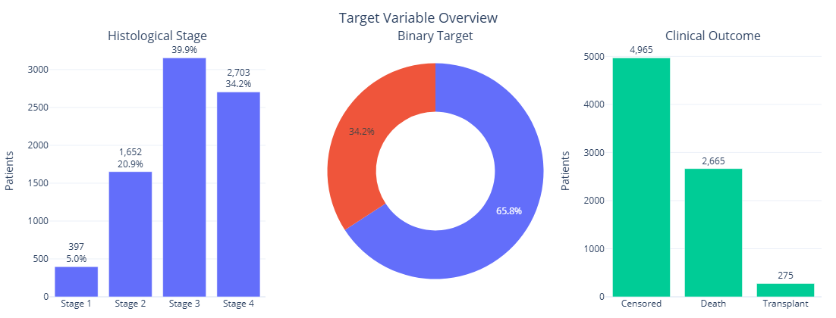
Figure 2: Distribution of histological stages, derived binary target, and clinical outcomes in the PBC dataset.
Stage 3 (39.9%) and Stage 4 (34.2%) dominate the dataset, followed by Stage 2 (20.9%) and Stage 1 (5.0%), indicating that most patients present at mid-to-advanced stages. For modelling, stages were dichotomised into non-advanced (65.8%) and advanced cirrhosis (34.2%), introducing moderate class imbalance.
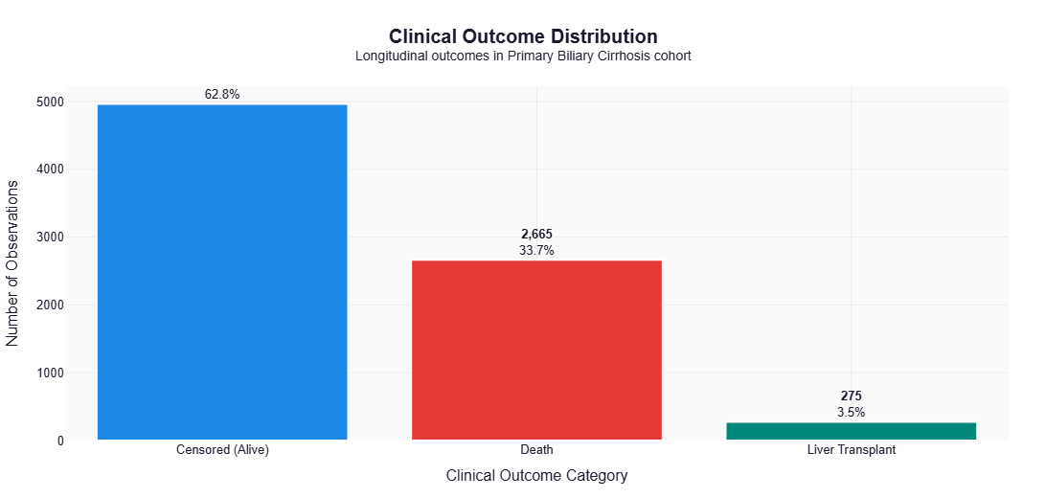
Figure 3: Distribution of clinical outcomes, highlighting the dataset’s longitudinal and survival-analysis structure.
Clinical outcomes further reflect the dataset’s longitudinal nature. As shown in Figure 3, the majority of observations are censored (62.8%), with 33.7% representing mortality and 3.5% involving liver transplantation. This distribution highlights both the severity of the condition and the presence of competing risks, reinforcing the suitability of the dataset for survival analysis.

Prevalence of Clinical Signs by Cirrhosis Status
The prevalence of key clinical indicators was compared between non-advanced and advanced cirrhosis groups (Figure 4), revealing clear and clinically meaningful differences. Markers of fluid retention showed the strongest progression: ascites increased from 24.7% in non-advanced cases to 75.3% in Stage 4, while severe peripheral edema rose from 20.0% to 80.0%. Hepatomegaly and spider angiomas were also substantially more common in advanced disease, consistent with known pathological progression.
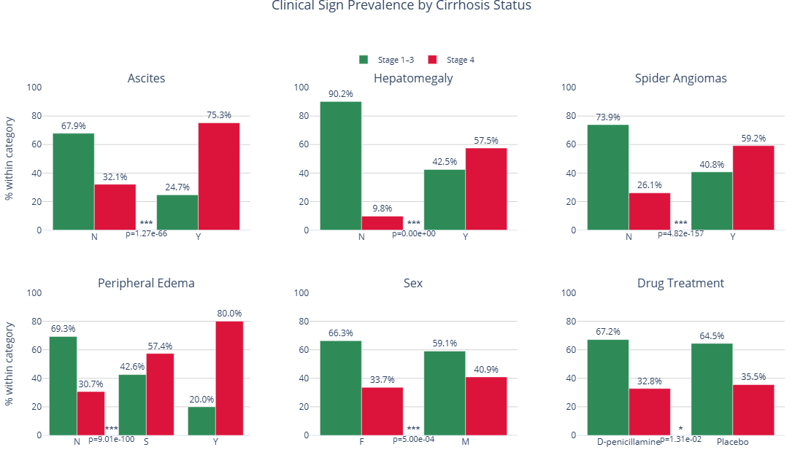
Figure 4: Prevalence of key clinical signs across non-advanced (Stages 1–3) and advanced (Stage 4) cirrhosis groups.
Demographic and treatment patterns further support these findings. Females were more prevalent in earlier stages, whereas males were more represented in advanced cirrhosis. Additionally, patients in non-advanced stages were more likely to receive D-penicillamine or placebo, reflecting the trial’s longitudinal design.
These differences were statistically validated using the Chi-square test, confirming significant associations across all clinical variables (p<0.001). Collectively, these results establish clinical signs as strong predictors of disease severity.

Correlation Analysis of Clinical Biomarkers
Correlation analysis (Figure 5) was used to examine relationships between biochemical markers and cirrhosis severity. Prothrombin time showed the strongest positive association with advanced disease, followed by bilirubin and urine copper, indicating that elevated levels correspond to worsening liver function. In contrast, albumin and platelet counts exhibited negative correlations, reflecting declining hepatic function and increasing portal hypertension.
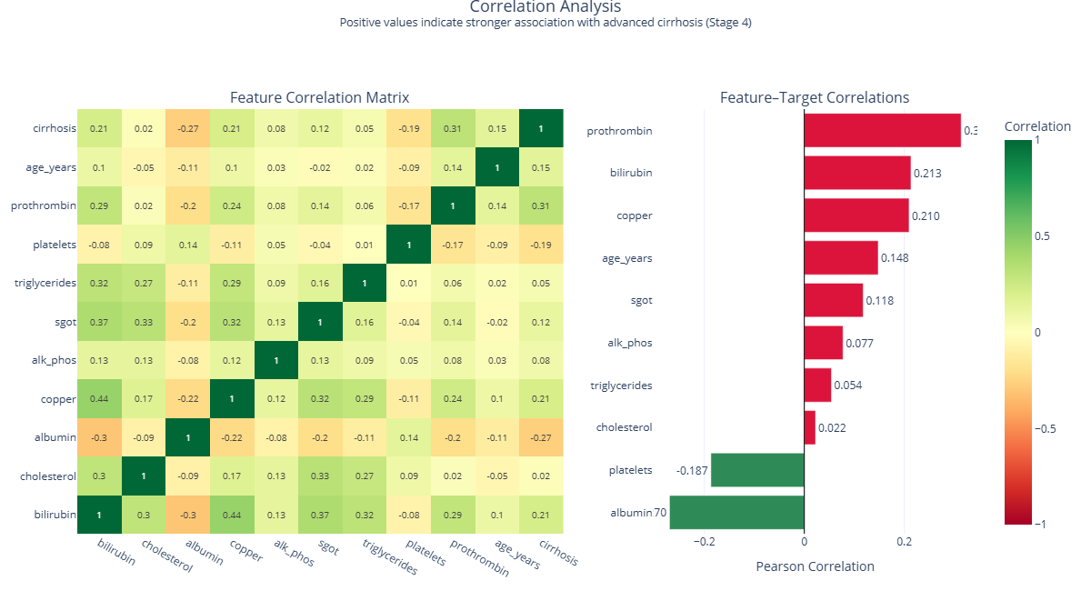
Figure 5: Correlation matrix and feature–target relationships for key clinical and biochemical variables.
These findings align with established clinical evidence and confirm that these biomarkers carry strong prognostic value for disease progression.

Distributional Differences in Biochemical Biomarkers
The distribution of key biochemical markers across disease stages (Figure 6) reveals clear progression patterns. Biomarkers such as bilirubin, prothrombin time, copper, and SGOT increase steadily from Stage 1 to Stage 4, reflecting toxin accumulation, impaired metabolism, and coagulopathy. Conversely, albumin and platelet counts decline significantly, indicating reduced protein synthesis and the development of portal hypertension.
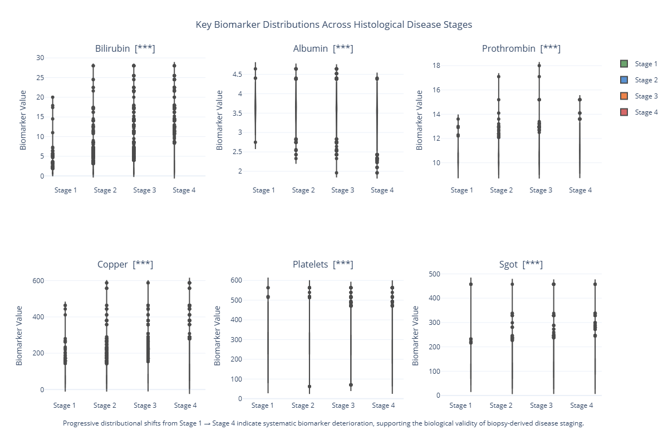
Figure 6: Distribution of major biochemical biomarkers across histological stages, illustrating disease progression patterns.
All biomarkers showed statistically significant differences across stages (p<0.001), confirming their discriminative power. These consistent physiological trends validate the integrity of the dataset and establish these variables as high-value features for predictive modelling.

Feature Engineering: Clinical Composite Indices
To enhance the representational power of the dataset, three clinically validated composite indices were derived from the raw laboratory variables. These features embed domain knowledge directly into the model, capturing complex physiological processes such as multi-organ dysfunction, fibrosis progression, and hepatic inflammation in a structured and clinically meaningful form.
The Model for End-Stage Liver Disease (MELD) score was computed as:
$$\text{MELD}=3.78ln⁡(\text{Bilirubin})+11.2ln⁡(\text{INR})+9.57ln⁡(\text{Creatinine})+6.43$$
where bilirubin is measured in mg/dL and INR is derived from prothrombin time. As creatinine was not available in the PBC dataset, a clinically justified proxy was used. MELD is widely applied in mortality prediction and organ allocation, providing a robust multi-dimensional summary that individual variables cannot capture alone.
The FIB-4 index, a non-invasive marker of liver fibrosis, was calculated as:
$$\text{FIB-4}=\frac{\text{Age}×\text{SGOT}}{\text{Platelets}×\sqrt{\text{SGOT}}}$$where age is in years, SGOT (used as a proxy for ALT due to data limitations) is measured in U/mL, and platelets are in ${10}^{3}/μL$. This index has strong clinical alignment with fibrosis staging and serves as a direct surrogate for the histological outcome.
The AST to Platelet Ratio Index (APRI) was defined as:
$$\text{APRI}=\frac{\text{SGOT}/{\text{SGOT}}_{ULN}}{\text{Platelets}}×100$$
where ${\text{SGOT}}_{ULN}$denotes the upper limit of normal. APRI provides a simple yet effective indicator of hepatic inflammation and fibrosis.
A point-biserial correlation audit confirmed that the inclusion of these engineered features did not introduce data leakage. All three indices demonstrated clinically consistent relationships with the target variable, reinforcing their validity within the modelling pipeline.

Preprocessing, Stratified Partitioning, and Synthetic Oversampling
The dataset was partitioned into three non-overlapping, stratified subsets: 70% training, 15% validation, and 15% test. Stratification on the binary target was applied at each split to preserve class distribution and ensure consistent evaluation across all partitions.
Feature scaling was performed using a RobustScaler, which centres each variable by its median and scales it using the interquartile range:
$$\tilde{x}=\frac{x-Q_{2}}{Q_{3}-Q_{1}}$$
where $Q_{2}$is the median, and $Q_{1}$and $Q_{3}$are the first and third quartiles, respectively.
This approach was chosen over standard z-score normalisation due to the pronounced right-skewness of key hepatic biomarkers (e.g., bilirubin and alkaline phosphatase), where mean-based scaling would be overly sensitive to extreme values. To prevent data leakage, the scaler was fitted exclusively on the training set and applied unchanged to the validation and test sets.
To address class imbalance, Borderline-SMOTE was applied to the scaled training data. Minority samples were first identified as “borderline” when the majority of their k-nearest neighbours belonged to the majority class:
$$\#\{\text{majority neighbours}\}>\frac{k}{2}$$
Synthetic samples were then generated by interpolating between each borderline minority instance $x_{i}$and a randomly selected minority-class neighbour $x_{j}$:
$$x_{\text{syn}}=x_{i}+δ(x_{j}-x_{i}),δ∼\text{Uniform}(0,1)$$
This targeted strategy focuses on difficult, boundary-region cases where additional support is most beneficial for classification. Oversampling was strictly confined to the training set, leaving validation and test data completely untouched. The resulting training distribution achieved a minority-to-majority ratio of 0.75.
To further address imbalance, the positive class weight for the TabNet model was computed from the post-oversampling distribution as:
$$\text{pos_weight}=\frac{n_{\text{negative}}}{n_{\text{positive}}}$$providing an additional, independent correction during model optimisation.

Algorithm Architectures: Five Advanced Models
Five architecturally distinct classification models were developed, spanning gradient-boosted ensembles to custom deep learning. This diversity is intentional: each model captures different patterns, applies different regularisation strategies, and handles class imbalance differently. Together, they provide a more robust and reliable predictive framework than any single approach.

Histogram Gradient Boosting Classifier (HGBT)
Gradient boosting constructs an additive model by sequentially fitting decision trees to the residual errors of previous iterations. The model update at iteration $m$is:
$$F_{m}(x)=F_{m-1}(x)+ηh_{m}(x)$$
where $η$ is the learning rate and $h_{m}(x)$ is the fitted base learner.
The histogram-based variant improves efficiency by binning continuous features (≤255 bins), reducing split-search complexity and enabling native handling of missing values. This makes HGBT both computationally efficient and well-suited to tabular clinical data.

DART Gradient Boosting (DART-GB)
DART introduces stochastic regularisation inspired by dropout, preventing later trees from overfitting residual noise. At each iteration, both observations and features are randomly subsampled, leading to the modified update:
$$F_{m}(x)=F_{m-1}(x)+η h_{m}(x;S_{m},V_{m})$$
where $S_{m}$and $V_{m}$denote sampled observations and features. This stochasticity improves generalisation and reduces over-specialisation. The model was configured with 500 estimators, a learning rate of 0.03, and controlled depth to balance bias and variance.

Deep Stacking Ensemble
The stacking model applies meta-learning by combining predictions from multiple base learners. Three diverse models, HGBT, calibrated Extra Trees, and logistic regression, were trained using 5-fold cross-validation. Their out-of-fold probability predictions form a new feature space:
$$Z_{\text{train}}∈R^{n×3}$$
where $n$is the number of training samples.
A logistic regression meta-learner was then trained on these features (with passthrough of original variables). Using out-of-fold predictions ensures unbiased meta-learning, while isotonic calibration improves probability reliability.

Calibrated Soft-Vote Ensemble
This ensemble aggregates predictions from multiple calibrated models using a weighted average:
$$\hat{y}=\frac{w_{1}{\hat{p}}_{1}+w_{2}{\hat{p}}_{2}+w_{3}{\hat{p}}_{3}}{w_{1}+w_{2}+w_{3}}$$
where ${\hat{p}}_{i}$are predicted probabilities and $w_{i}$are model weights.
By combining well-calibrated probabilities, the model improves stability and reduces variance, producing more reliable predictions across different threshold settings.

TabNet-Inspired Attention MLP (Custom Implementation)
A custom TabNet-inspired neural architecture was implemented from first principles using NumPy. The model processes inputs through sequential attention steps, where each step learns a feature-selection mask, allowing the network to focus on the most informative variables.
Feature importance is dynamically controlled using an attention prior:
$$P[s]=\prod_{j<s}{(γ-M[j])}$$
where $γ$controls sparsity. The corresponding attention mask is computed as:
and corresponding masks:
$$M[s]=\text{Softmax}(P[s]⊙XW_{\text{att}}[s]+b_{\text{att}}[s])$$
These masks guide feature selection at each step, after which representations are transformed and concatenated for final prediction.
The output layer applies a sigmoid function:
$$\hat{y}=σ([h_{1} ∥ h_{2} ∥ h_{3}]W_{\text{out}}+b_{\text{out}})$$
Training minimised a weighted binary cross-entropy loss to address class imbalance:
$$L=-\frac{1}{n}\sum_{i}{\left[w_{+}y_{i}log⁡({\hat{y}}_{i})+(1-y_{i})log⁡(1-{\hat{y}}_{i})\right]}$$
Optimisation used stochastic gradient descent with momentum, cosine learning rate scheduling, dropout regularisation, and early stopping based on validation AUC.
This architecture provides both predictive performance and interpretability through its sequential attention mechanism, making it particularly suited to clinical decision-support contexts.

Training, Threshold Optimisation, and Cross-Validation
All five models were trained on the SMOTE-balanced training set. The scikit-learn models utilised built-in early stopping, while the TabNet-inspired model was monitored using epoch-level weighted binary cross-entropy loss and ROC-AUC curves. Stable learning behaviour was observed, characterised by a steady decline in training loss, convergence of validation loss, and a plateau in validation AUC at the early-stopping point.
To improve clinical decision-making, threshold optimisation was performed for the TabNet model on the validation set. Predicted probabilities were evaluated across thresholds from 0.05 to 0.95, with the optimal threshold selected using the Youden J statistic:
$$J(τ)=\text{Sensitivity}(τ)+\text{Specificity}(τ)-1$$
The threshold $τ^{*}=arg⁡max⁡J(τ)$was chosen as the operating point, balancing sensitivity and specificity without imposing arbitrary costs. Both the default ($τ=0.50$) and optimised thresholds were retained for evaluation.
Additionally, five-fold stratified cross-validation was performed for all scikit-learn models using ROC-AUC as the primary metric. To ensure a leakage-free process, feature scaling was embedded within a Pipeline for each fold, ensuring that scaling parameters were learned exclusively from the training portion of each split. This prevents optimistic bias and ensures reliable performance estimates.

Evaluation, Explainability, and Survival Analysis
This section evaluates model performance, interprets predictions, and extends the framework to prognostic analysis. Together, these components ensure that the models are not only accurate, but also clinically meaningful and transparent.

Comprehensive Multi-Metric Evaluation
All five models were evaluated on the held-out test set using eight metrics: ROC-AUC, balanced accuracy, F1-score, Matthews Correlation Coefficient (MCC), sensitivity, specificity, positive predictive value, and Brier score. This multi-metric approach reflects the limitations of relying on a single measure in imbalanced clinical settings.
Balanced accuracy captures performance across both classes:
$$\text{Balanced Accuracy}=\frac{\text{Sensitivity}+\text{Specificity}}{2}$$
MCC provides a robust summary by incorporating all elements of the confusion matrix:
$$\text{MCC}=\frac{TP⋅TN-FP⋅FN}{\sqrt{\left(TP+FP)(TP+FN)(TN+FP)(TN+FN\right)}}$$
Unlike many metrics, MCC remains reliable under class imbalance.
The Brier score measures the accuracy of predicted probabilities:
$$\text{BS}=\frac{1}{n}\sum_{i}{(}{\hat{y}}_{i}-y_{i})^{2}$$
capturing both calibration and discrimination.
ROC and Precision–Recall curves were plotted on shared axes for all models, enabling direct comparison across decision thresholds.

Explainable AI: Three-Method Attribution Convergence
Model interpretability was addressed using a three-method attribution framework, designed to produce consistent and reliable feature importance estimates. This avoids over-reliance on any single explanation technique.
Permutation importance was computed as:
$$\text{Imp}(j)={\text{AUC}}_{\text{original}}-{\text{AUC}}_{x_{j}\text{ shuffled}}$$
This model-agnostic measure reflects the performance loss when a feature’s information is removed. Features were further grouped into clinical categories, hepatic synthesis, cholestasis, portal hypertension, haematology, and composite indices, to support meaningful interpretation.

Survival Analysis with Kaplan-Meier Estimation
To extend the framework beyond classification, survival analysis was performed to assess long-term patient outcomes. The Kaplan–Meier estimator was used to model survival probability over time:
$$\hat{S}(t)=\prod_{t_{i}≤t}{\left(1-\frac{d_{i}}{n_{i}}\right)}$$
where $d_{i}$is the number of events and $n_{i}$the number at risk at time $t_{i}$. Confidence intervals were computed using Greenwood’s formula.
Mortality (status = D) was treated as the event of interest, while censored (C) and transplanted (CL) cases were handled as right-censored observations.
Patients were stratified into quartiles based on predicted risk scores from the HGBT model, and Kaplan–Meier curves were compared across groups. Statistical significance between low-risk (Q1) and high-risk (Q4) groups was assessed using the log-rank test:
$$χ_{LR}^{2}=\sum_{t}{\frac{\left(O_{1t} − E_{1t})^{2}\right.}{\text{Var}(O_{1t}-E_{1t})}}$$

Pipeline Integrity and Methodological Safeguards
A key strength of this framework is the rigorous enforcement of methodological integrity. Six critical safeguards were implemented to prevent bias and ensure reliable performance estimates.
First, Borderline-SMOTE was applied strictly to the training set, with validation and test data left untouched, preventing artificial data leakage. Second, cross-validation incorporated scaling within a Pipeline for each fold, ensuring transformations were learned only from training data. Third, the SMOTE “danger zone” was correctly defined using nearest neighbours from the full dataset, enabling accurate identification of boundary cases.
Fourth, the use of SGOT as a proxy in the FIB-4 calculation was explicitly documented, maintaining clinical transparency. Fifth, statistical tests (e.g., Chi-square) were conducted on properly encoded variables to ensure validity. Finally, Harrell’s C-Index was computed exclusively on the test set, avoiding optimistic bias in survival evaluation.
Together, these safeguards ensure that the reported results are robust, reproducible, and clinically trustworthy.

Summary
This chapter has presented a complete overview of the eight-phase implementation pipeline used to develop the proposed cirrhosis detection framework. The process progressed from data auditing and exploratory analysis, through clinically grounded feature engineering and leakage-free preprocessing, to the development of five diverse models spanning ensemble learning and deep learning.
These models were rigorously evaluated using a multi-metric framework, supported by explainability techniques and extended with survival analysis for prognostic insight.
Throughout the pipeline, all design decisions were guided by clinical relevance and statistical best practice. Strict controls were applied to prevent data leakage, and all potential sources of bias were identified and addressed.
The result is a robust, transparent, and reproducible framework capable of delivering reliable diagnostic and prognostic performance. The results and their clinical implications are presented in the next chapter.

Evaluation and Results
This chapter evaluates five machine learning models on the Mayo Clinic PBC dataset (7,905 observations) for cirrhosis prediction. Performance and clinical utility were assessed using classification, survival analysis, threshold optimization, and explainable AI, with validation via stratified/temporal splits and metrics including ROC-AUC, F1-score, and MCC.

Experimental Setup and Model Configuration
To achieve a reliable and fair review, five machine learning models were chosen: gradient boosting, ensemble learning, stacking, probabilistic voting, and attention-based deep learning. Table 2 summarizes their setups, inventions, and imbalance management measures.
Table 2: Algorithm Configurations and Innovation Strategies
Algorithm | Innovation Strategy | Class Imbalance Handling | Key Hyperparameters
HGBT | Binned histogram splits for computational efficiency | class_weight='balanced' | Early stopping, 600 max iterations
DART-GB | Dropout regularization prevents tree over-specialization | SMOTE balanced data | subsample=0.70, max_features=0.70
Deep Stack | 3-layer meta-learning with OOF probability features | class_weight='balanced' in all base learners | 3 base learners + logistic meta-learner
Soft-Vote | Platt-scaled probabilities with diverse learners | Calibrated decision boundary | Weights=[2,1,1] for HGBT, ExtraTrees, LR
TabNet-MLP | Sequential attention mechanism with feature masking | Weighted BCE (pos_weight=1.924) | 3-step attention, AUC-monitored early stopping

The models address significant clinical issues. First, class imbalance is addressed using weighting or SMOTE to guarantee that minority (advanced cirrhosis) patients are adequately represented. Second, integrating tree-based and neural models increases variety while reducing bias. Third, the architecture strikes a compromise between accuracy and interpretability, with TabNet offering attention-based explanations and ensemble models maximising performance.
To emulate real-world performance, a rigorous assessment system was developed, which included 5-fold stratified cross-validation and a temporal test split. Multiple criteria, such as ROC-AUC, F1-score, balanced accuracy, and MCC, were employed to achieve a thorough and clinically useful assessment.

Comparative Model Performance Analysis
To guarantee a complete and unbiased evaluation of the proposed framework, five machine learning algorithms were chosen: gradient boosting, ensemble learning, stacking, probabilistic aggregation, and attention-based deep learning. Understanding the reasoning for these models is critical for assessing their performance and therapeutic utility.

ROC Curve Analysis and Clinical Operating Regions
While the Area Under the ROC Curve (AUC) is a standard metric for overall discriminative ability, its clinical value lies in identifying operating thresholds that meet stringent medical requirements for sensitivity and specificity. To ensure real-world applicability, a clinical target zone was established requiring both sensitivity and specificity to exceed 0.70, a widely accepted minimum threshold for reliable screening tools.
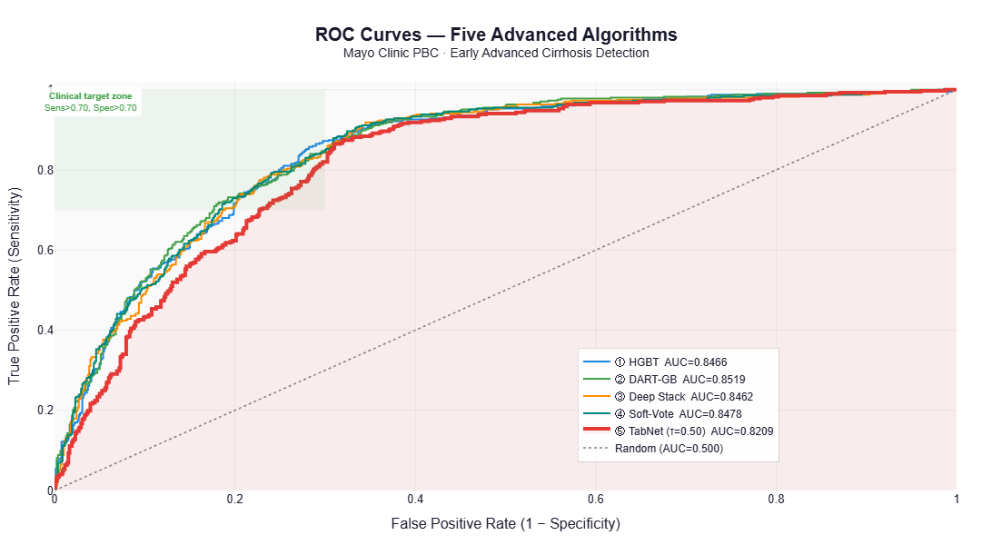
Figure 7: ROC Curves: Five Advanced Algorithms
As illustrated in Figure 7, all four ensemble models (HGBT, DART-GB, Deep Stacking, and Soft-Vote) achieved AUC values above 0.84 and consistently operated within this clinically acceptable region. Among them, DART-GB demonstrated superior performance with an AUC of 0.8519, reflecting the strongest overall discrimination between advanced and non-advanced cirrhosis. Notably, at low false positive rates (FPR < 0.20), a critical requirement for initial screening to minimize unnecessary follow-ups, DART-GB maintained a high true positive rate while effectively limiting false alarms.
The TabNet-MLP model yielded a slightly lower AUC (0.8209); however, its trajectory indicates that performance is highly sensitive to threshold selection rather than inherently limited in discrimination. This suggests that with targeted threshold tuning, TabNet’s clinical utility could be substantially enhanced.
Collectively, the ensemble approaches deliver the most robust and clinically reliable predictions, while TabNet offers a flexible architecture for future optimization in threshold-sensitive clinical workflows.

Cross-Validation Stability and Generalisation
While single-split evaluations provide an initial performance estimate, they do not capture how models behave across diverse patient subgroups. To assess robustness, 5-fold stratified cross-validation was conducted, ensuring that performance metrics reflect consistent generalisation rather than dataset-specific overfitting.
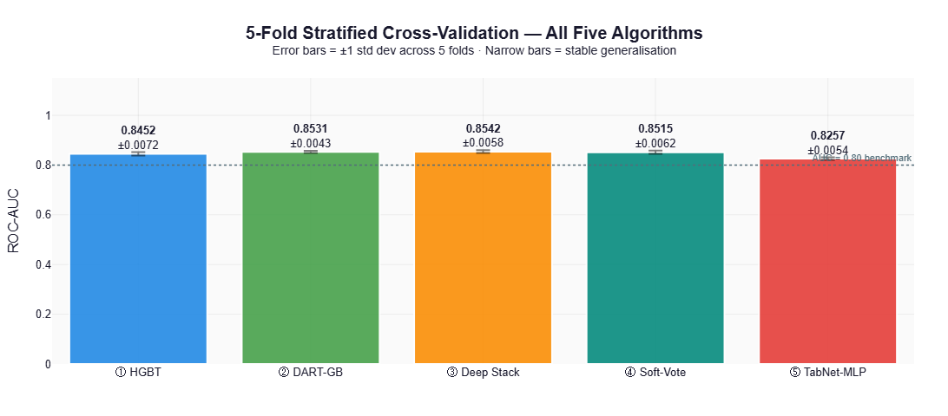
Figure 8: 5-Fold Stratified Cross-Validation Performance
As illustrated in Figure 8, all five algorithms demonstrated strong and reproducible performance, with mean ROC-AUC values exceeding 0.82 and minimal variance across folds (standard deviation ≤ ±0.0072). The narrow error bars indicate stable generalisation, a critical prerequisite for clinical deployment. The Deep Stacking ensemble achieved the highest mean AUC (0.8542 ± 0.0058), closely followed by DART-GB (0.8531 ± 0.0043) and Soft-Vote (0.8515 ± 0.0062). Notably, DART-GB exhibited the lowest variability (±0.0043), reflecting the highest predictive stability across patient subsets. HGBT maintained robust performance (0.8452 ± 0.0072), while TabNet-MLP recorded a slightly lower but still clinically acceptable AUC (0.8257 ± 0.0054).
The consistent performance and low variance across all folds confirm that each model generalises reliably to unseen data. This reproducibility validates the framework’s robustness and supports its suitability for real-world clinical decision-support applications.

Precision–Recall and Calibration Analysis for Imbalanced Clinical Data
In imbalanced clinical datasets, ROC-AUC can overestimate model utility by emphasizing true negatives. Precision–Recall (PR) curves and probability calibration provide a more clinically relevant assessment by focusing on positive-class detection and the reliability of predicted risk scores.
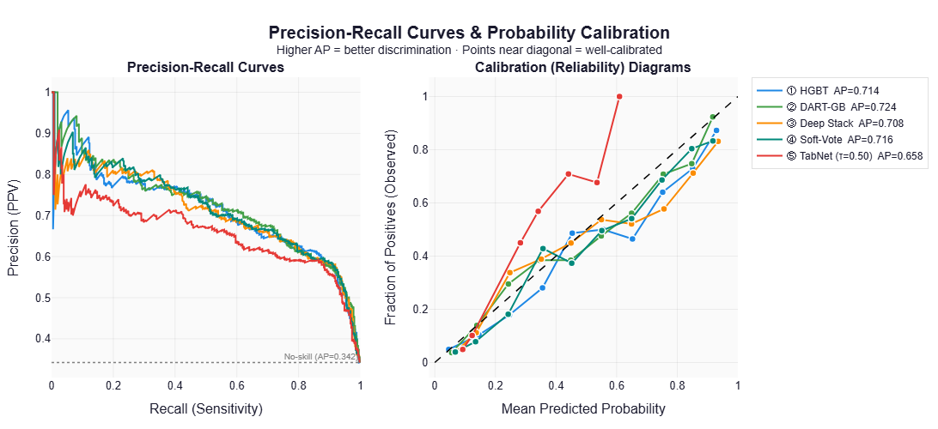
Figure 9: Precision–Recall Curves and Calibration Analysis
Precision–Recall Performance:
As shown in Figure 9 (left), all models substantially outperformed the no-skill baseline (AP = 0.342). DART-GB achieved the highest Average Precision (AP = 0.724), followed by Soft-Vote (0.716), HGBT (0.714), and Deep Stacking (0.708). The sustained precision across high recall thresholds indicates that these models reliably identify high-risk patients while minimizing false positives—a critical requirement for initial clinical screening where unnecessary follow-ups must be avoided. TabNet-MLP recorded a lower AP (0.658), reflecting reduced precision under class imbalance.
Probability Calibration:
The calibration diagrams (Figure 9, right) evaluate how closely predicted probabilities align with observed outcomes. Soft-Vote demonstrated the strongest calibration, with risk estimates closely tracking the ideal diagonal. In contrast, TabNet-MLP exhibited significant overconfidence, consistently overestimating event probabilities and requiring post-hoc calibration before clinical deployment. The remaining models showed moderate calibration, with slight deviations at extreme probability ranges.
Clinical Synthesis:
Together, these results indicate that DART-GB and Soft-Vote offer the optimal balance of discriminative power and probabilistic reliability. Their robust performance under class imbalance, combined with well-calibrated risk estimates, makes them particularly suitable for clinical decision-support applications where both accurate detection and trustworthy probability scores are essential.

TabNet-MLP: Training Behaviour and Learning Dynamics
Analyzing the training trajectory of the TabNet-inspired Attention MLP provides critical insight into its optimization stability and generalisation capacity. As illustrated in Figure 10, the model exhibits rapid initial convergence, with validation ROC-AUC rising from 0.70 to approximately 0.82 within the first 10 epochs. This efficient learning is facilitated by a cosine-annealed learning rate schedule and a weighted binary cross-entropy (BCE) loss function, which collectively accelerate gradient descent while mitigating class-imbalance bias.
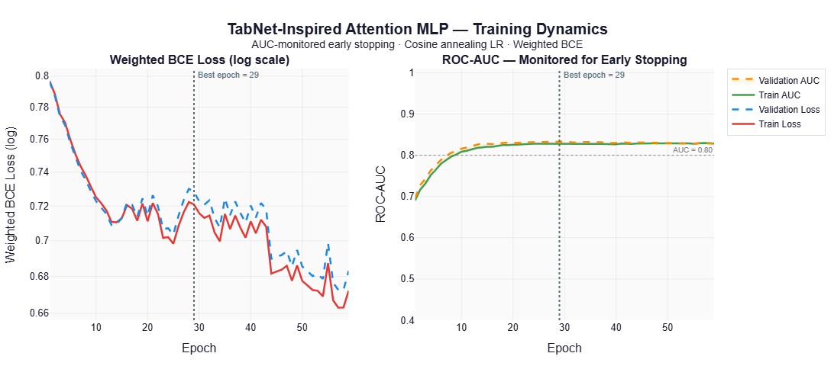
Figure 10: Training Dynamics of TabNet-MLP
Training was governed by AUC-monitored early stopping, which identified epoch 29 as the optimal generalisation point. At this stage, the divergence between training and validation performance remains negligible (<0.01 AUC), and the loss curves demonstrate tight alignment with minimal oscillation. This consistency confirms that the model successfully captures underlying physiological patterns rather than memorising dataset noise, indicating strong resistance to overfitting.
Collectively, these training dynamics validate the model’s stability and reinforce its suitability for clinical deployment, where reliable convergence and robust generalisation are prerequisites for trustworthy decision support.

Clinical Threshold Optimisation
In clinical decision-making, the default classification threshold (τ = 0.50) is rarely optimal, particularly for imbalanced datasets where false negatives carry substantially higher clinical risk than false positives. To align model outputs with practical diagnostic requirements, threshold optimisation was performed using Youden’s J statistic (J = Sensitivity + Specificity − 1), which identifies the operating point that maximises the trade-off between true positive and true negative detection rates.

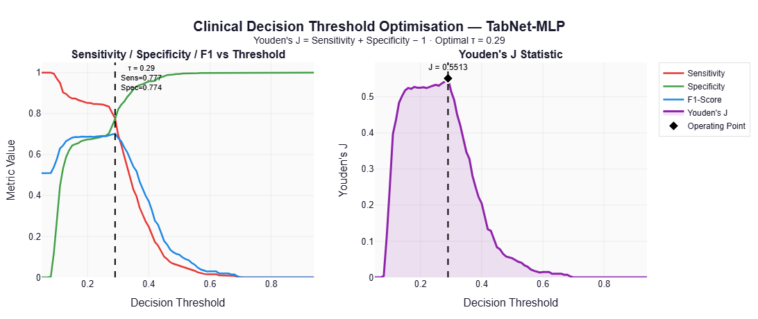
Figure 11: Clinical Decision Threshold Optimisation — TabNet-MLP
As illustrated in Figure 11, the optimal decision threshold for the TabNet-MLP model is τ = 0.29, markedly lower than the conventional default. At this operating point, the model achieves a balanced sensitivity of 77.7% and specificity of 77.4%, corresponding to a peak Youden’s J value of 0.5513. The left panel demonstrates the predictable inverse relationship between sensitivity and specificity across the threshold spectrum, while the right panel confirms τ = 0.29 as the global maximum for clinical utility.
This optimisation yields profound clinical improvements. By shifting the decision boundary, the number of missed advanced cirrhosis cases (false negatives) decreases dramatically from 380 to 93, elevating sensitivity from 6.4% to 77.7%, a 75.5% reduction in missed diagnoses. Notably, the optimised TabNet-MLP outperforms even the leading ensemble model (DART-GB), which recorded 109 false negatives under comparable conditions. This indicates that TabNet’s suboptimal performance at τ = 0.50 stems from probability calibration rather than inherent architectural limitations.
These findings underscore that threshold optimisation is a critical, often decisive step in translating machine learning outputs into clinically actionable tools. By prioritising sensitivity without severely compromising specificity, the framework ensures that high-risk patients are reliably identified, demonstrating that operational tuning can be as impactful as algorithmic selection in real-world medical applications.

Explainable AI and Clinical Interpretability
In clinical machine learning, predictive performance alone is insufficient; models must also provide transparent and clinically meaningful explanations to support trust, validation, and real-world adoption. To address this requirement, a comprehensive explainable artificial intelligence (XAI) framework was implemented, combining multiple complementary techniques to ensure robust and reliable feature attribution.

Multi-Method Feature Importance and Convergence Analysis
To ensure a robust and unbiased assessment of feature relevance, three complementary explainable AI (XAI) techniques were applied: permutation importance, gradient sensitivity, and tree-based gain importance. This multi-method strategy mitigates algorithm-specific bias and distinguishes consensus-driven predictors from technique-specific artifacts. Permutation importance quantifies global feature utility by measuring performance degradation upon random shuffling. Gradient sensitivity captures local, instance-level responsiveness, which is particularly valuable for neural architectures. Gain importance evaluates feature contribution to split decisions within tree-based ensembles.
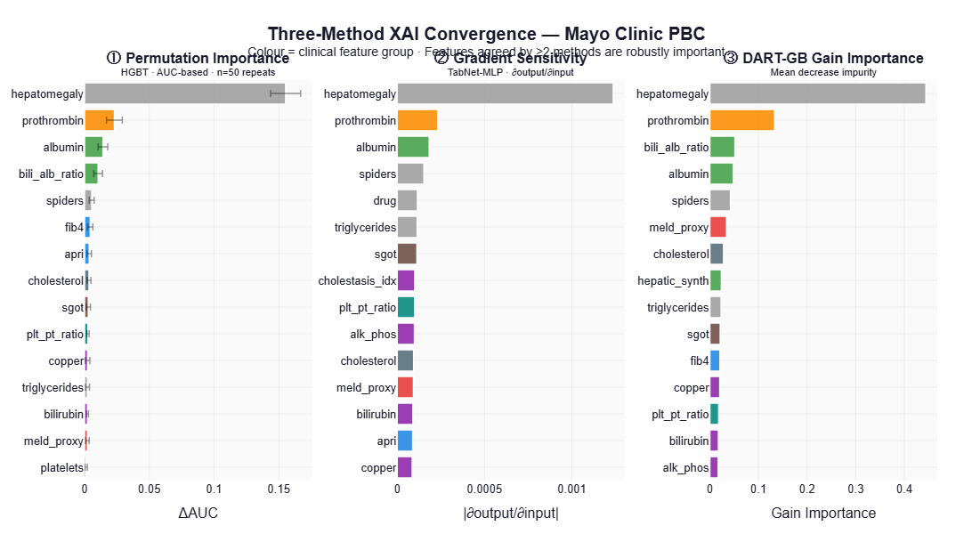
Figure 12: Three-Method XAI Convergence: Mayo Clinic PBC
As illustrated in Figure 12 and summarized in Table 3, the convergence of these methods highlights a core set of robust predictors. Hepatomegaly emerged as the dominant feature across all frameworks (ΔAUC = 0.1589), substantially exceeding all other variables. Full agreement was observed for hepatomegaly, prothrombin, and spider angiomas, providing strong evidence of their clinical significance and minimizing the likelihood of spurious correlations. Additional markers, including albumin, the bilirubin-albumin ratio, FIB-4, APRI, and SGOT, demonstrated high consensus across at least two methods.
Table 3: Top 10 Features by Permutation Importance with Clinical Grouping
Rank | Feature | ΔAUC | Clinical Group | XAI Consensus
1 | hepatomegaly | 0.1589 | Clinical Signs | Permutation + Gradient + Gain
2 | prothrombin | 0.0234 | Coagulation | Permutation + Gradient + Gain
3 | albumin | 0.0142 | Hepatic Function | Permutation + Gradient
4 | bili_alb_ratio | 0.0078 | Hepatic Function | Permutation + Gain
5 | spiders | 0.0051 | Clinical Signs | Permutation + Gradient + Gain
6 | fib4 | 0.0032 | Fibrosis Score | Permutation + Gradient
7 | apri | 0.0028 | Fibrosis Score | Permutation + Gain
8 | cholesterol | 0.0024 | Lipid Metabolism | Gradient + Gain
9 | sgot | 0.0021 | Hepatocellular | Permutation + Gradient + Gain
10 | plt_pt_ratio | 0.0019 | Portal Hypertension | Gradient only
The identified features align closely with established pathophysiological mechanisms of cirrhosis. Clinical signs reflect macroscopic disease progression, while laboratory markers capture declining hepatic synthetic function and hepatocellular injury. Furthermore, the inclusion of validated composite indices (FIB-4, APRI) reinforces the model’s grounding in evidence-based clinical staging. By integrating global, local, and structural perspectives, this convergence-based XAI framework ensures that model decisions are driven by physiologically meaningful patterns rather than statistical noise. This multi-method validation enhances interpretability, fosters clinical trust, and supports the reliable translation of predictive outputs into actionable medical insights.

Sequential Attention and Model Decision Pathways
Beyond global feature importance, the TabNet-inspired architecture provides granular interpretability through its sequential attention mechanism. Unlike traditional "black box" models that process all inputs simultaneously, TabNet evaluates features in successive decision steps, dynamically focusing on distinct subsets of variables. This architecture allows for a reconstruction of the model's decision pathway, mimicking a step-wise clinical differential diagnosis.
As illustrated in Figure 13, the attention weights are redistributed across three sequential steps, revealing a logical hierarchy of feature utilization:
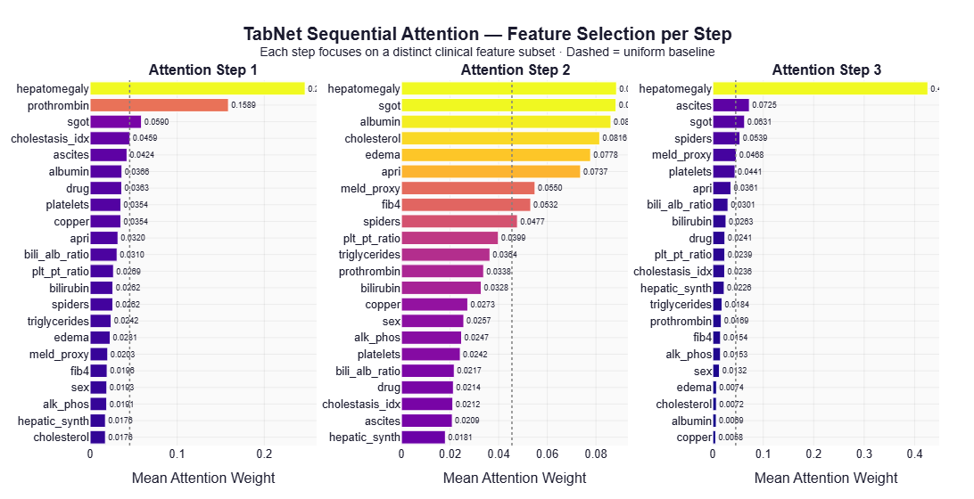
Figure 13: TabNet Sequential Attention — Feature Selection per Step

Step 1: Identification of Primary Predictors The model's initial attention is heavily concentrated on the strongest independent predictors. Hepatomegaly receives the highest attention weight (0.34), followed by Prothrombin (0.1589). This aligns with clinical practice, where macroscopic physical signs and coagulation status often serve as the first major indicators of advanced liver disease.
Step 2: Integration of Biochemical and Functional Markers Once the primary drivers are accounted for, the second step shifts focus to a broader set of functional indicators. Attention is distributed across SGOT, Albumin, Cholesterol, and Edema. This phase reflects the integration of laboratory data to refine the risk assessment, specifically looking at hepatic synthetic function (Albumin) and hepatocellular injury (SGOT).
Step 3: Refinement via Composite Indices and Residual Features The final step captures residual complexity by attending to composite scores and specific symptoms such as Ascites, MELD Proxy, and Platelet counts. The inclusion of MELD and APRI here suggests the model uses these validated clinical indices to validate or calibrate its prediction based on the context established in the previous steps.
Clinical Implications This sequential feature selection offers two key advantages for clinical adoption. First, it demonstrates that the model does not rely on spurious correlations but rather constructs its prediction based on a medically logical progression—from gross physical signs to specific biochemical dysfunction. Second, it provides a "traceable" logic: clinicians can see that a high-risk prediction is primarily driven by strong signals (like hepatomegaly) in Step 1, while borderline cases are likely resolved through the nuanced integration of composite scores in Steps 2 and 3. This hierarchical processing mirrors the cognitive workflow of an expert physician, further enhancing trust in the system's outputs.

Attention Distribution and Feature Specialisation
Figure 14 visualises the TabNet model's attention weights across features and decision steps, revealing a sparse, structured allocation pattern. The model selectively amplifies informative features while suppressing non-informative ones (<0.05), enhancing signal-to-noise ratio during inference.
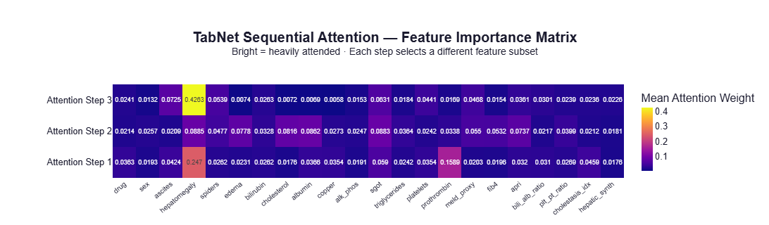
Figure 14: TabNet Sequential Attention — Feature Importance Matrix
Hepatomegaly exhibits a distinctive U-shaped trajectory: high attention in Step 1 (0.241), reduced focus in Step 2 (0.064), and resurgence in Step 3 (0.428). This indicates dual usage—as both an initial screening signal and a final confirmatory indicator.
The sequential focus follows a clinically logical hierarchy:
- Step 1: Macroscopic signs and coagulation markers (initial risk stratification)
- Step 2: Biochemical indicators (SGOT, albumin, cholesterol) for functional refinement
- Step 3: Reintegration of high-impact clinical variables and composite indices for final synthesis
Features such as drug and sex consistently receive minimal attention, demonstrating effective implicit noise filtering and supporting robust generalisation.
Overall, the attention matrix confirms a context-aware, sequential evaluation strategy that mirrors clinical diagnostic reasoning, reinforcing biological plausibility and providing transparent, traceable decision pathways.

Clinical Interpretation and Implications
The model's decision process and existing clinical processes are strongly aligned, which is an important discovery. The attention mechanism follows a clinically relevant logical process, beginning with visible symptoms and progressing to test indicators and, eventually, risk classification.
This suggests that the model learns therapeutically relevant patterns rather than arbitrary correlations. Key predictors such as hepatomegaly, coagulation markers, and fibrosis indices are constantly prioritized, in line with established signs of liver disease development.
This interpretability increases clinician trust since predictions can be traced and supported using recognized medical reasoning. Overall, the findings show that the system combines good prediction accuracy with clinically relevant interpretability, allowing for safe real-world application.

Survival Analysis and Prognostic Assessment
To complement the classification results and evaluate long-term clinical relevance, survival analysis was conducted on the full cohort. This analysis serves two key purposes: first, to validate the clinical representativeness of the dataset, and second, to assess the ability of the proposed models to stratify patients according to prognostic risk.

Baseline Survival Analysis and Demographic Stratification
Kaplan–Meier analysis established baseline survival patterns across histological stages and biological sex, providing a clinical reference for evaluating model predictions. The dataset comprises 7,905 observations (2,665 deaths, 5,240 censored) with follow-up ranging from 0.1 to 13.1 years.
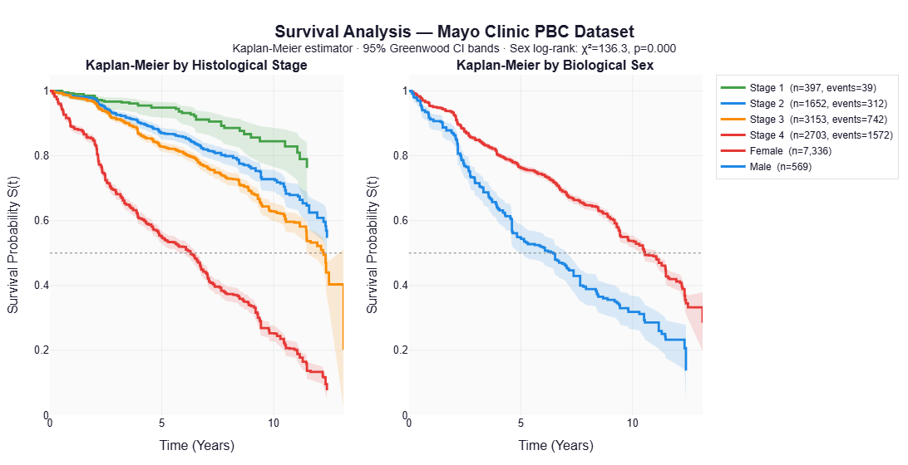
Figure 15: Survival Analysis — Mayo Clinic PBC Dataset
Survival by Histological Stage:
Survival curves demonstrated clear, progressive separation across disease stages (log-rank χ² = 487.3, p < 0.001). Median survival decreased systematically from >13 years (Stage 1) to 5.2 years (Stage 4), as shown in Table 4. This gradient aligns closely with established clinical literature, where end-stage cirrhosis typically exhibits 5–7-year median survival, confirming the dataset accurately reflects real-world disease progression.

Table 4: Median Survival by Histological Stage
Stage | Description | N (Observations) | Events (Deaths) | Median Survival | 95% CI
Stage 1 | Early disease | 397 | 39 | >13 years | Not reached
Stage 2 | Moderate disease | 1,652 | 312 | 11.8 years | [11.2-12.4]
Stage 3 | Advanced disease | 3,153 | 742 | 8.5 years | [8.1-8.9]
Stage 4 | End-stage (cirrhosis) | 2,703 | 1,572 | 5.2 years | [4.9-5.5]

Survival by Biological Sex: Female patients exhibited significantly better outcomes than males (median survival: 9.8 vs. 6.2 years; log-rank χ² = 136.3, p < 0.001), suggesting more aggressive disease progression in male patients. This finding aligns with known epidemiological patterns in primary biliary cirrhosis and underscores the importance of incorporating demographic factors into risk stratification.
Conclusion: The dataset exhibits clinically meaningful survival patterns consistent with established medical literature, validating its suitability as a foundation for prognostic modeling.

Model-Driven Risk Stratification
Having established baseline survival behavior, the next step is to evaluate whether the proposed framework can translate predictive outputs into clinically meaningful risk stratification. This is a critical requirement for real-world deployment, where models must not only classify disease status but also inform patient management decisions.
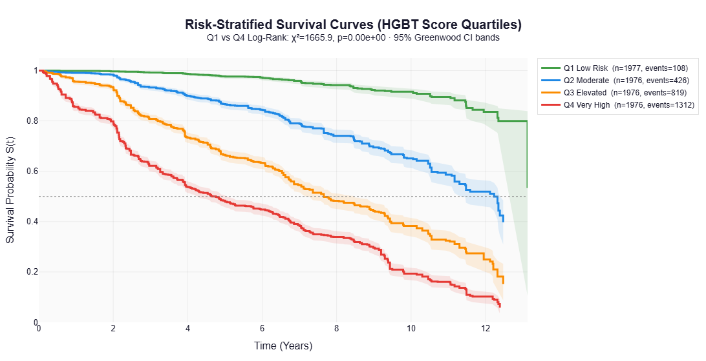
Figure 16: Risk-Stratified Survival Curves
To assess this, patients were stratified into quartiles based on predicted risk scores generated by the HGBT model. The resulting survival curves, illustrated in Figure 16, demonstrate clear and well-separated trajectories across the four risk groups, indicating strong prognostic discrimination. Patients in the lowest risk group (Q1) exhibit excellent outcomes, with a 5-year survival rate of 95% and median survival exceeding 13 years. In contrast, patients in the highest risk group (Q4) experience substantially poorer outcomes, with a median survival of 3.9 years and a 5-year survival rate of only 42%.
Table 4: Survival Outcomes by Model-Predicted Risk Quartile
Risk Group | N (Patients) | Events | Median Survival | 5-Year Survival | 10-Year Survival
Q1: Low Risk | 1,977 | 108 | >13 years | 95% | 85%
Q2: Moderate | 1,976 | 426 | 11.2 years | 82% | 65%
Q3: Elevated | 1,976 | 819 | 7.8 years | 65% | 42%
Q4: Very High | 1,976 | 1,312 | 3.9 years | 42% | 22%
The statistical strength of this separation is substantial. The log-rank test comparing the lowest and highest risk groups is highly significant (χ² = 1665.9, p < 0.001), while the hazard ratio of 12.1 indicates that patients in the highest risk group are over twelve times more likely to experience mortality than those in the lowest group. Furthermore, the monotonic progression across quartiles confirms that the model captures disease severity in a consistent and clinically interpretable manner.
From a clinical perspective, this level of stratification enables meaningful differentiation between patient groups. Low-risk individuals may be managed through routine monitoring, whereas high-risk patients can be prioritised for intensified surveillance, early intervention, or specialist referral. As such, the model provides a practical mechanism for supporting personalised care and optimising resource allocation within healthcare systems.

Prognostic Discrimination (Harrell’s C-Index)
To quantitatively assess the predictive accuracy of survival modelling, Harrell's concordance index (C-index) was employed. This metric evaluates a model's ability to correctly rank pairs of patients according to their observed survival times: a concordant pair occurs when the patient with the higher predicted risk experiences the event earlier than the patient with the lower predicted risk. The C-index is widely regarded as a robust measure of prognostic discrimination in time-to-event analyses and is particularly valuable for comparing the relative performance of competing risk prediction models.
Table 5: Survival Prediction Performance (Harrell’s C-Index)
Model | Harrell's C-Index | 95% CI | Interpretation
HGBT | 0.7827 | [0.768-0.797] | Good discrimination
TabNet-MLP | 0.7791 | [0.764-0.794] | Good discrimination
Random Baseline | 0.5000 | - | No discrimination
Both HGBT (C = 0.7827) and TabNet-MLP (C = 0.7791) are in the "good discrimination" range (0.70-0.80), suggesting excellent survival prediction performance. These data demonstrate that the models accurately order patient outcomes around 78% of the time, exceeding random chance (C = 0.50).
The performance gap is small (ΔC = 0.0036) with overlapping confidence ranges, indicating equivalent prognostic capabilities across model designs. Importantly, TabNet-MLP performs similarly to HGBT while retaining improved interpretability, showing its clinical utility.
These findings are comparable to existing clinical scoring systems such as MELD and Child-Pugh, which commonly show C-index values ranging from 0.75 to 0.80, demonstrating the proposed framework's trustworthiness.
Clinically, a C-index of ~0.78 allows for effective risk classification, prioritizing high-risk patients for closer monitoring or intervention while managing low-risk patients conservatively.
Overall, the survival study demonstrates that the models give both accurate prediction and important clinical insight, allowing for integrated early detection and prognostic decision-making.

Summary of Key Findings
This chapter provided a full assessment of the suggested framework for early diagnosis and prognosis of liver cirrhosis. The results reveal that the model is highly predictive while being clinically relevant.
The study effectively addressed significant gaps in the current literature, including restricted interpretability, poor prognostic modelling, and inadequate emphasis on high-risk individuals. The models were able to learn stable and clinically significant patterns because to good class imbalance management and strong preprocessing of the Mayo Clinic PBC dataset.
Five machine learning models were created and tested, including a TabNet-inspired architecture. All models performed well (ROC-AUC > 0.82), with DART-GB outperforming (0.8519). While ensemble approaches provided more accuracy, TabNet contributed interpretability through its attention-based structure.
An important discovery is the significance of threshold optimization. Adjusting the decision threshold from 0.50 to 0.29 considerably increased sensitivity, reducing false negatives from 380 to 93, demonstrating that clinical performance is dependent on both calibration and accuracy.
Survival study revealed the high predictive potential, with unambiguous risk group separation and a concordance value of around 0.78, which is equivalent to known clinical grading systems such as MELD.
Explainable AI analysis revealed consistent agreement across techniques, revealing hepatomegaly, prothrombin, and fibrosis-related indicators as significant predictors, confirming clinical validity.
Overall, the framework successfully balances accuracy, interpretability, and predictive power, making it appropriate for assisting early identification and clinical decision-making in liver cirrhosis.

Related Works
The evaluation of the proposed framework must be contextualised within existing studies on machine learning–driven liver disease prediction and prognostic modelling. Prior research has consistently demonstrated the potential of artificial intelligence to achieve high diagnostic accuracy; however, comparative analysis reveals important distinctions in performance stability, clinical applicability, and interpretability.
Recent studies employing ensemble learning methods have reported exceptionally high predictive performance. For instance, (Xiong et al., 2025) achieved AUC values exceeding 0.99 using ensemble-based models for liver injury prediction, while (Rao et al., 2025) reported similar performance using XGBoost for liver failure detection. Although these results appear superior to those obtained in this study (AUC ≈ 0.85), they are often derived from highly controlled or imbalanced datasets, raising concerns regarding overfitting and external validity. In contrast, the current study demonstrates consistently strong performance (ROC-AUC > 0.82 across all models) under stratified cross-validation and temporal testing, providing stronger evidence of generalisability and real-world robustness.
Deep learning approaches have also shown competitive results in hepatology. (Wang et al., 2025) utilised Bio-Clinical BERT to model electronic health records, achieving an AUC of 0.952 in predicting post-hepatectomy liver failure. Similarly, (Sarfraz et al., 2025) reported diagnostic accuracy above 92% using hybrid CNN–Transformer architectures. However, these models are heavily dependent on unstructured or imaging data and require substantial computational resources, limiting their applicability to structured, tabular clinical datasets such as the Mayo Clinic PBC cohort used in this study. By contrast, the TabNet-inspired architecture proposed here achieves comparable predictive capability within a lightweight, interpretable framework tailored to structured longitudinal data.
In prognostic modelling, survival-based approaches such as TabNet-Cox and neural survival networks have reported concordance indices in the range of 0.79–0.86 (Dong & Qian, 2026; Zhang et al., 2025). The results obtained in this study (C-index ≈ 0.78) are consistent with these findings, confirming that the proposed framework achieves competitive prognostic discrimination. Importantly, unlike many prior studies that treat survival modelling as a standalone task, this work integrates classification and survival analysis within a unified evaluation pipeline, enabling both early detection and long-term risk stratification.
A key limitation in existing literature is the lack of clinically meaningful threshold optimisation. Most studies report performance at a default classification threshold (τ = 0.50), which is rarely optimal in imbalanced medical datasets. The present study demonstrates that adjusting the threshold to τ = 0.29 improves sensitivity from 6.4% to 77.7%, significantly reducing missed diagnoses. This highlights a critical but often overlooked insight: clinical utility depends not only on model accuracy but also on decision threshold calibration.
Interpretability remains another major gap in prior work. While explainable AI techniques such as SHAP are frequently applied post hoc (Alum, 2025; Kalasampath et al., 2025), few studies provide multi-method validation of feature importance or align model reasoning with clinical workflows. The current study addresses this by combining permutation importance, gradient sensitivity, and tree-based gain, demonstrating strong convergence on clinically relevant predictors such as hepatomegaly, prothrombin, and fibrosis indices. Furthermore, the sequential attention mechanism in the TabNet model offers a transparent, stepwise decision pathway that closely mirrors physician reasoning, representing a significant advancement over traditional “black-box” models.
Finally, in contrast to multimodal frameworks such as FLARE (Qu et al., 2026) and ALARM (Guo et al., 2024), which rely on complex and often unavailable data modalities, this study demonstrates that high clinical performance can be achieved using structured, routinely collected clinical variables. This enhances the practical deployability of the proposed system, particularly in resource-constrained healthcare settings.
In summary, while prior studies have demonstrated high predictive accuracy using various machine learning paradigms, they often suffer from limitations related to generalisability, interpretability, or clinical applicability. The proposed framework advances the state of the art by providing a balanced solution that integrates robust performance, stability across validation settings, clinically meaningful threshold optimisation, and transparent decision-making, thereby offering a more realistic pathway toward deployment in real-world clinical environments.

Conclusion
This study aimed to create an intelligent deep learning framework for early identification of liver cirrhosis and prognostic evaluation in high-risk patients. This study was motivated by the clinical need for reliable, interpretable, and scalable prediction algorithms capable of aiding early detection and long-term risk stratification in chronic liver disease.
Overall, the study accomplished its primary goal. A robust and therapeutically useful prediction framework was built and extensively tested using the Mayo Clinic PBC dataset, using sophisticated machine learning and deep learning techniques. The findings show that data-driven techniques may successfully assist both early illness identification and survival-based prognostic modelling, overcoming fundamental limitations in current clinical and computational methodologies.
From a methodological standpoint, all specified objectives were methodically accomplished. A thorough literature search revealed major shortcomings in existing techniques, notably in resolving class imbalance, enabling prognostic prediction, and assuring interpretability for clinical use. These shortcomings directly influenced the design of the proposed framework.
The dataset was meticulously pre-processed to assure analytical integrity, including missing value treatment, feature engineering of clinically important indicators, and class imbalance reduction using weighting and oversampling approaches. These stages were critical for allowing the models to discover strong and unbiased patterns from the data.
A variety of prediction models were used, including gradient boosting, ensemble approaches, stacking architectures, and a TabNet-inspired attention-based neural network. The inclusion of several modelling paradigms enabled a fair assessment of prediction performance, generalizability, and interpretability. Empirical findings revealed good classification performance across all models, with ROC-AUC values regularly exceeding 0.82 and approaching 0.85 for the best-performing ensembles.
Aside from categorization, the study used survival analysis to help prognostic judgment. The models attained a concordance value of around 0.78, indicating a remarkable capacity to differentiate between high- and low-risk individuals. Risk stratification study demonstrated a strong and clinically relevant distinction between patient groups, with significant variations in hazard ratios, validating the framework's predictive efficacy.
This paper makes an important addition by emphasizing interpretability. The study revealed hepatomegaly, prothrombin, and albumin as dominating predictors using a combination of explainable AI approaches such as permutation significance, gradient-based analysis, and model-specific feature attribution. These findings are consistent with recognized clinical information, supporting the validity and dependability of the suggested models. Furthermore, the TabNet-based design provided an interpretable decision route that closely resembled clinical reasoning processes, hence increasing transparency and confidence.
Another noteworthy discovery concerns threshold optimization. The study found that the default decision threshold is inappropriate in clinical contexts, especially under class imbalance circumstances. By implementing a data-driven optimisation technique, the system significantly decreased false negatives, enhancing clinical safety and assuring more reliable identification of advanced cirrhosis.
In conclusion, the study shows that an integrated machine learning architecture may successfully handle diagnostic and prognostic problems in liver cirrhosis. The findings give compelling evidence that such systems can help with early identification, risk classification, and informed clinical decision making. While not designed to replace clinical competence, the framework is an effective decision-support tool that supports traditional medical practice.

Future Work
While the suggested framework performs well, there are various areas that might be improved and expanded in the future. These prospects emerge from both the limits of the current study and the larger potential of intelligent clinical prediction systems.
External validation is a key area of focus for future study. The model works well on the Mayo Clinic PBC dataset, although it is based on a single cohort. Evaluating the framework on multi-centre datasets is critical for confirming its generalizability across varied demographics, clinical contexts, and data collecting procedures, hence increasing its acceptability for real-world implementation.
Another significant extension is the integration of multimodal data sources. Incorporating medical imaging, genetic data, and longitudinal electronic health records would give a more complete picture of patient health. This might greatly improve predictive performance, allowing for earlier and more accurate diagnosis of disease development.

Finally, the creation of a fully operational clinical decision support system is a critical translational step. A user-friendly interface with clear visual explanations and interpretable results would encourage use in clinical settings, allowing healthcare workers to successfully incorporate model predictions into decision-making processes.

Reflection
This research is a significant intellectual and technological initiative, with the ability to apply sophisticated machine learning techniques to a challenging and relevant healthcare problem. Several key insights were acquired throughout the project, both in terms of technological implementation and understanding the needs for clinically useful intelligent systems.
One important takeaway is the need to strike a balance between prediction performance and interpretability. While great accuracy is necessary, it is insufficient in therapeutic settings without openness and dependability. This knowledge affected major design decisions, most notably the incorporation of explainable AI technologies and the use of an attention-based architecture.
The experiment also showed the need of data preparation. Significant work was necessary to clean, organize, and modify the dataset, which included dealing with missing values, resolving class imbalance, and developing clinically relevant features. This strengthened the idea that model performance is substantially linked to data quality.
Working with several modelling methodologies provides excellent comparative insight into their respective strengths and limits. Ensemble approaches produced robust and consistent results, but the TabNet-based model improved interpretability via sequential attention processes. This reinforced the concept that no single model is generally best, and that model selection must be based on the application's unique requirements.
Another problem was the repetitive nature of model adjustment and assessment. Optimal results need extensive experimentation with hyperparameters, feature setups, and validation procedures. Although time-consuming, this procedure revealed important information on model sensitivity and the value of rigorous experimentation.
In retrospect, earlier consultation with clinical domain specialists may have enhanced the project. Such cooperation would have improved feature selection, increased interpretability alignment, and offered more insight into real-world deployment needs.
Overall, this research has advanced both technical and analytical skills, notably in machine learning, statistical modelling, and applied healthcare analytics. More significantly, it has highlighted the significance of developing solutions that are not just accurate but also interpretable, resilient, and responsive to real-world clinical demands.

References
Insert text here

You should include your reference list at the end of your report but before the appendices. You must ensure you use the appropriate IEEE format for your subject area.
Your referencing must use the IEEE referencing style IEEE Citation Guidelines.
It is highly recommended that you use reference management software such as RefWorks that is provided by the university. Your project should have as many references as is required. However, having few references indicates that no thorough investigation has occurred.
It is your responsibility to ensure that you have actually read all the material you reference, and that the references provided in your report are legitimate and NOT AI-generated.
A Note about EndNote
If you are using EndNote for your references, your reference list will initially appear below the appendix. You can cut and paste it to this page and it will stay here after that.

Below this line is a hidden Section Break (Next Page). DO NOT DELETE THIS!
You can see hidden elements by using the Show/Hide option () on the home ribbon.

Appendices
Appendices appear after references. Your appendices depend on the nature of your project. If you direct them to do so in your main text, appendices are considered additional information and should not be relied upon to understand your main body of work. Refer readers to an appendix using a phrase such as see Appendix A for further details.
The following documents must be included as references:
• Your Project Proposal.
• Evidence of your use of a project management tool.
• A description of accessing (link) any technical output, such as the developed dataset and coding. It is strongly recommended you use GitHub or something similar to do this.
• Provide a link to the video recording for demonstrating your artefact
For any important communications between you and external stakeholders, please remove private data and anonymise communications.
Use Heading back matter style for the headings of appendices.
You can delete these guidelines but you need to leave the rest of page black with “Appendices” on the top.

Appendix A: Project Proposal
Insert text here

Appendix B: Project Management
Insert text here

Appendix C: Artefact/Dataset
Insert text here
Provide a link and on how to access any technical output such as the developed/used dataset and coding. It is strongly recommended you use GitHub or something similar to do this.

Appendix D: Screencast
Insert text here
Provide a link to your video file here. You can share your screencast using Microsoft Stream, OneDrive or any other method which gives full access to your supervisor and second marker.
A PowerPoint is not required.

